**Project 3**

Step1: Create two Linux instances, Use the first free Linux AMI

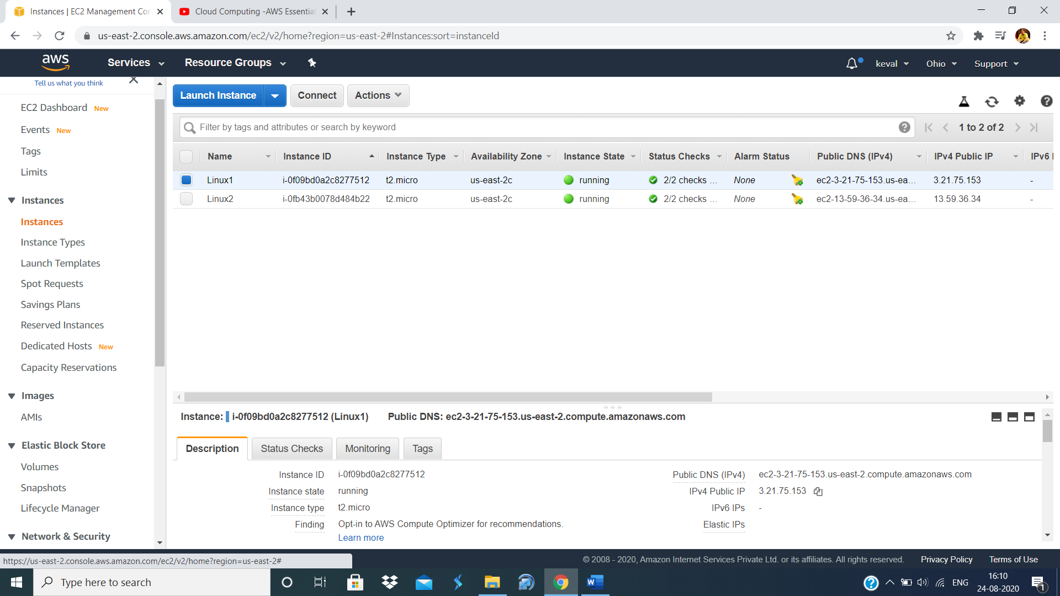

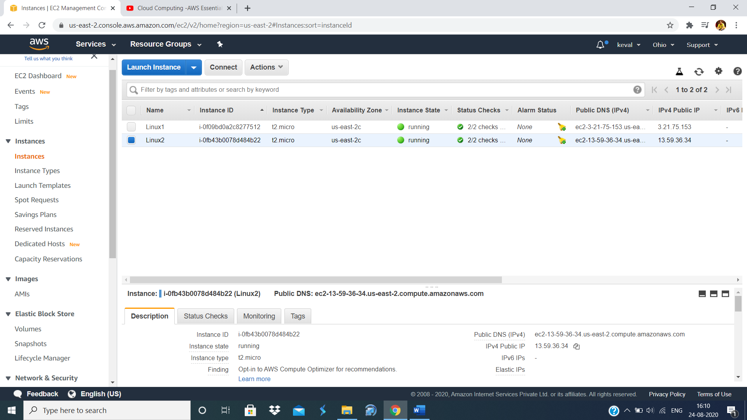

Step2: Launch both instances using Mobaxterm

Linux1

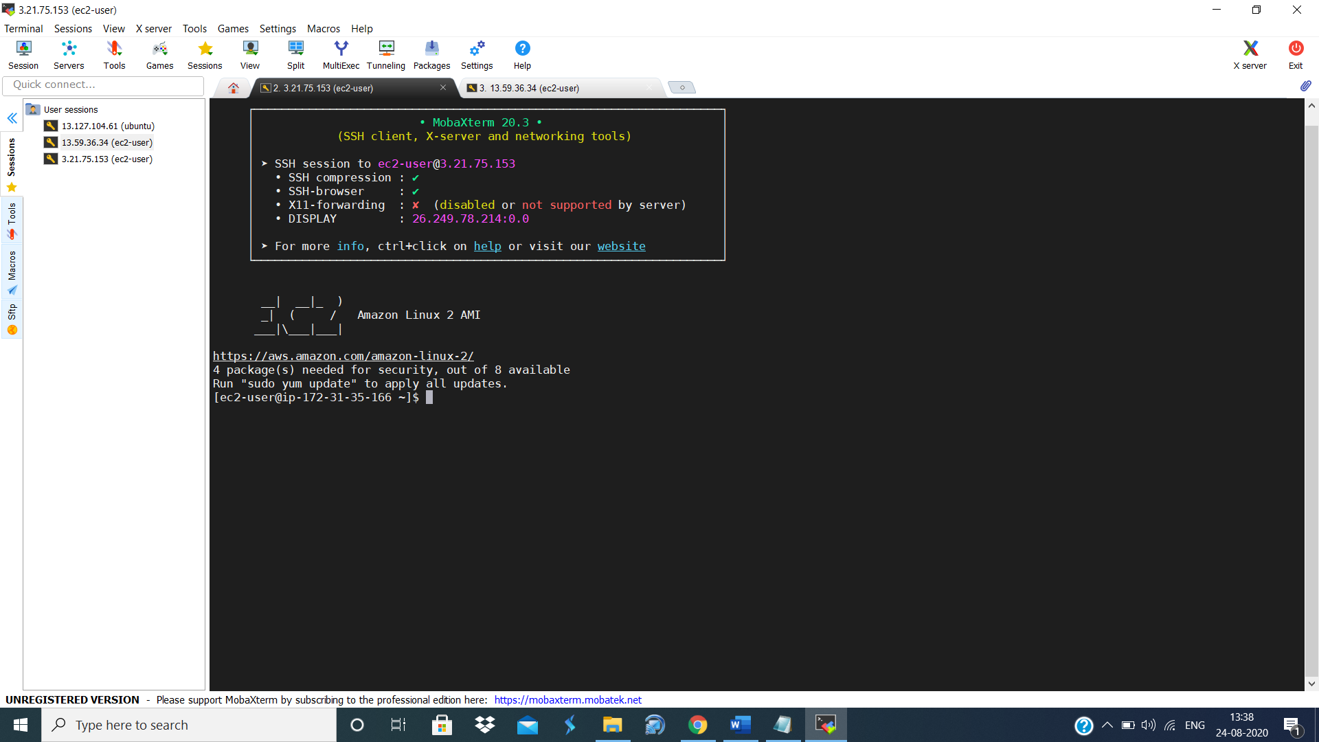

Linux2

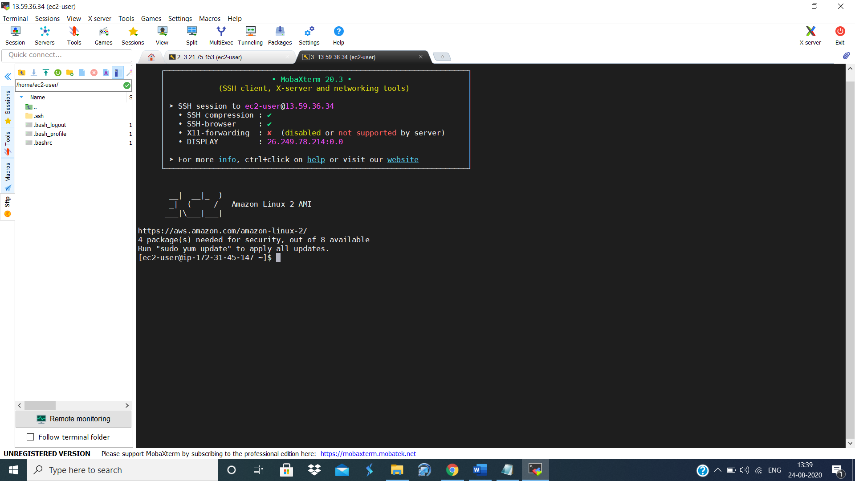

Step3: Host html login webpage on both servers

Linux1

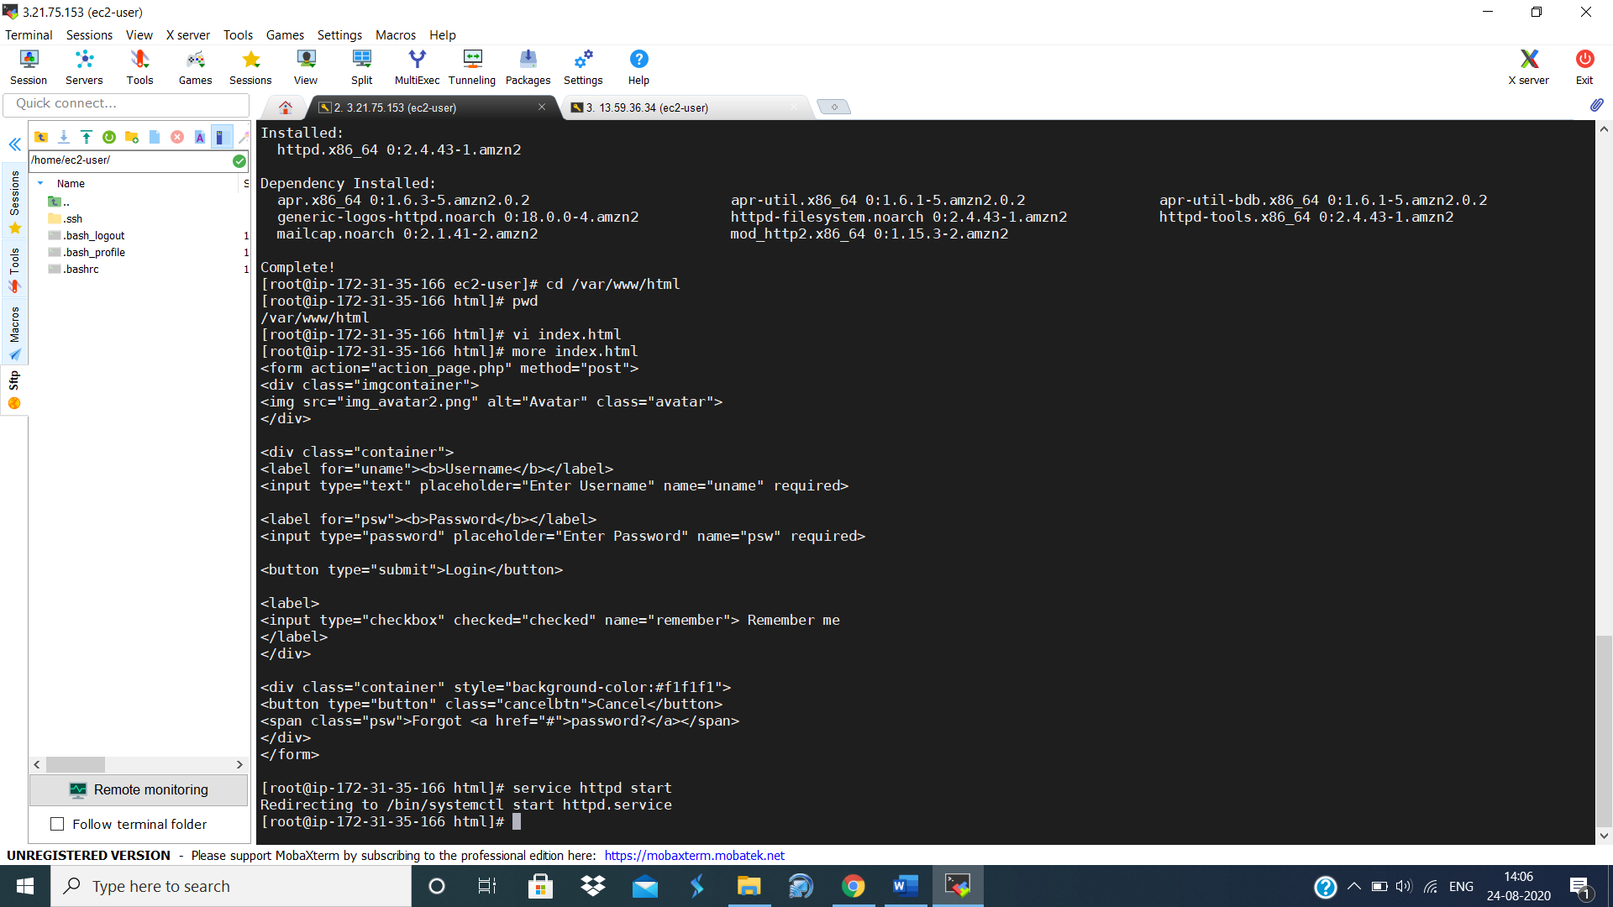

Linux2

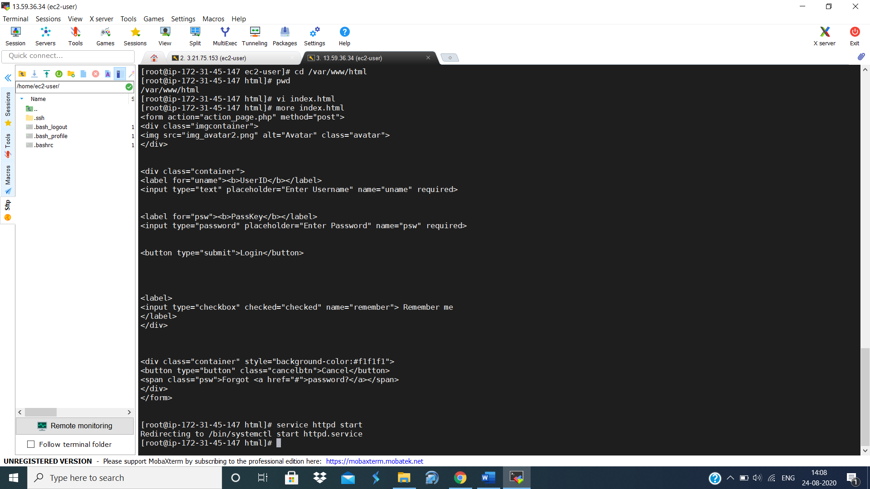

Step4: Check if the application is deployed on both servers by copy pasting the public IP of the servers into the browser.

Linux1

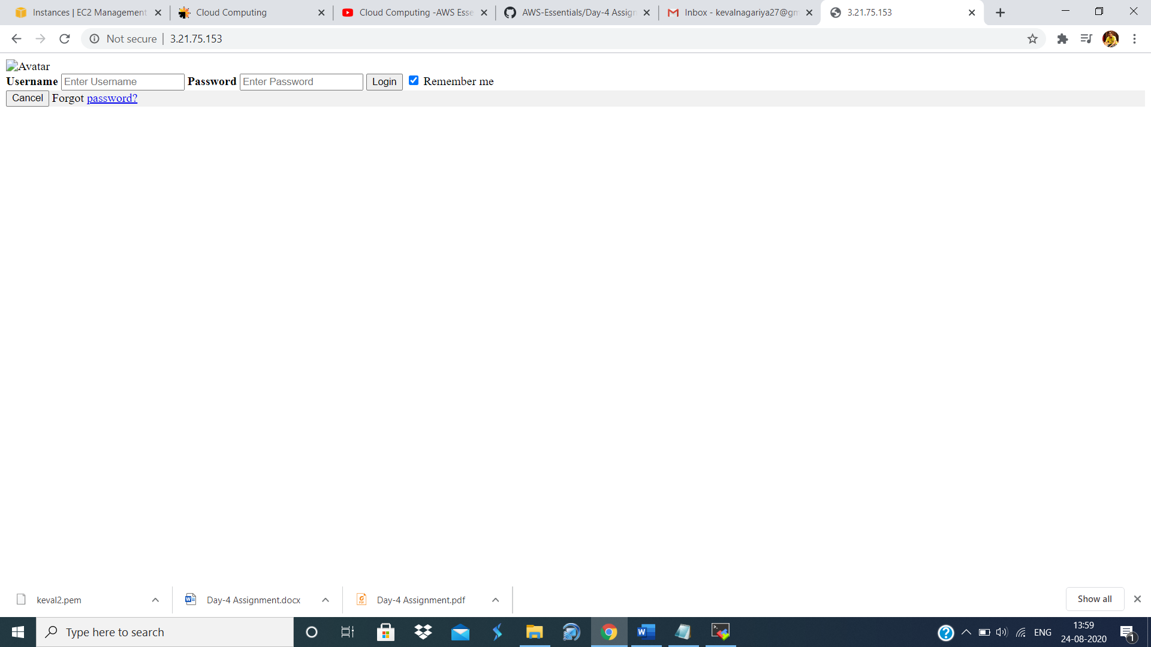

Linux2

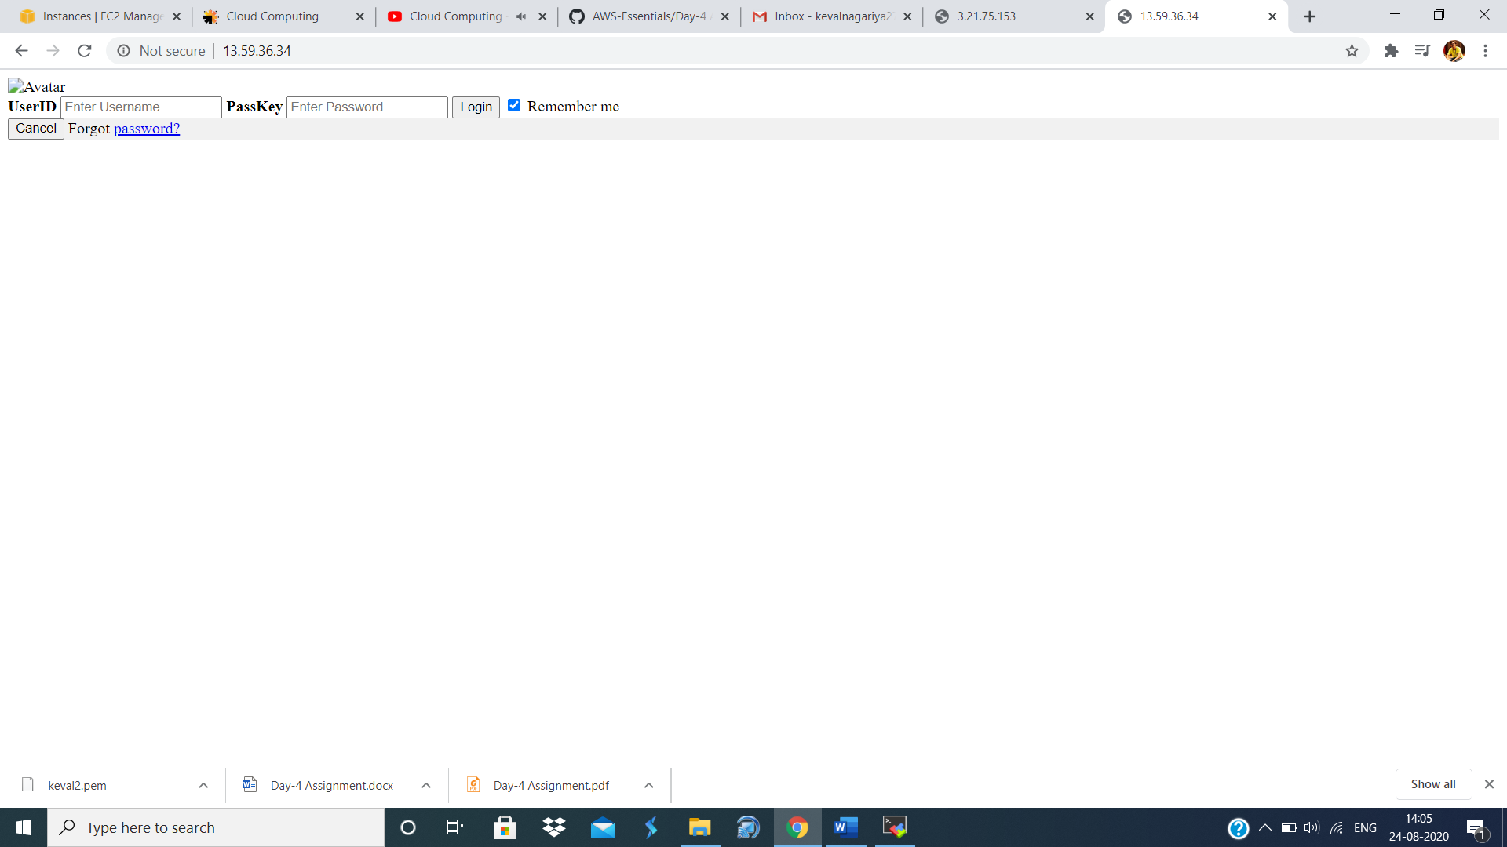

Step5: Create an application Load balancer with the above two instances as targets

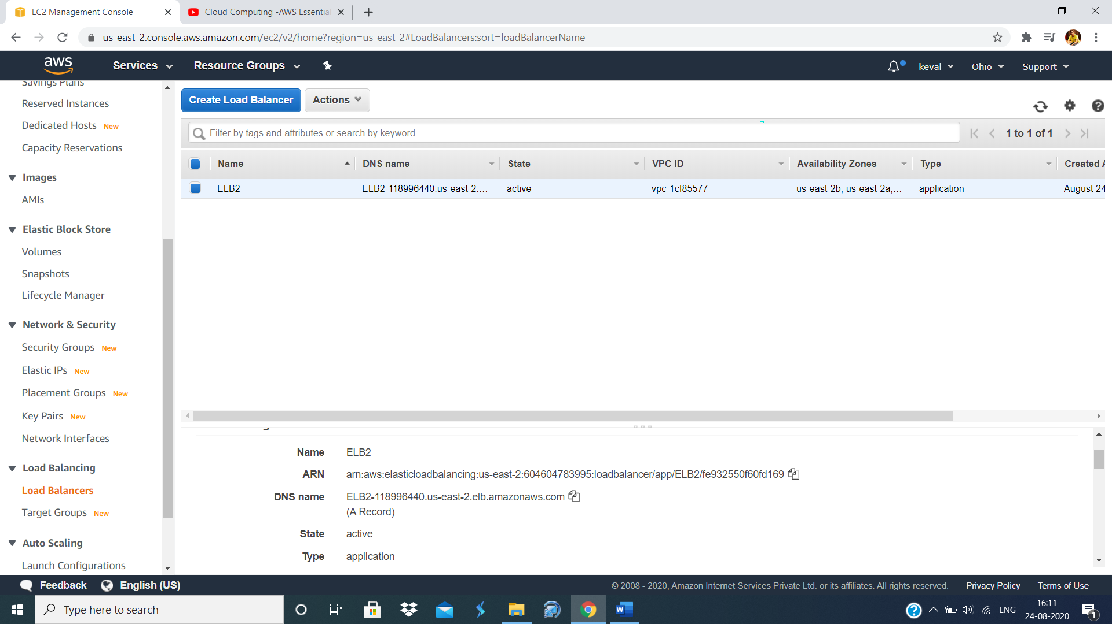

Step6: Check the functioning of ELB

